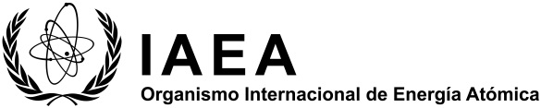
Programa de cooperación técnica (CT)

Proposal of national project

Project Title:
Suggested Field of Activity: | Please refer to the list of FoAs and select as appropriate.
Overall Objective:

Expected Outcome:
Problem to be addressed
Nuclear techniques(s) to be used in addressing the problem
Link to CPF/ National Development Plan:
Main Counterpart Institution:
Main Counterpart and Contact Details:

Véanse las definiciones (en inglés únicamente) del glosario TC Programme Planning and Design Glossary del servicio de referencias del MGCP: PCMF Reference Desk.

