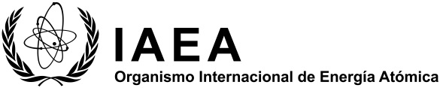
Programa de cooperación técnica (CT)

Proposal of regional project

Project Title:
Suggested Field of Activity: | Please refer to the list of FoAs and select as appropriate.
Overall Objective:
Expected Outcome:
Problem to be addressed
Nuclear technique(s) to be used in addressing the problem
Link to Regional Cooperative Framework/Regional Development Priorities/
Regional Strategic Profile:
Designated Team Member (DTM) and Contact Details:

For definition, please refer to the TC Programme Planning and Design Glossary available from the PCMF Reference Desk.

